LI-FI BASED DATA TRANSMISSION
USING SOFTWARE SIMULATION
(A Li-Fi Communication Concept Demonstrated through Arduino/ESP32 Software Simulation on Wokwi)

1. Project Idea / Abstract
Li-Fi (Light Fidelity) is a wireless communication technology that uses visible light to transmit data instead of radio waves, as used in conventional Wi-Fi. In a real Li-Fi system, data is transmitted by rapidly switching an LED on and off (imperceptible to the human eye) and received by a photodiode or light sensor that converts the light pulses back into electrical signals.
Since a physical light sensor / photodiode receiver is not required for demonstrating the core logic, this project presents a Software Simulation of Li-Fi data transmission using an Arduino/ESP32 board simulated on Wokwi. The transmitter side is real hardware behaviour (an LED blinking according to binary data), while the receiver side is simulated in software — the same program that encodes the message also decodes the recorded bit stream, proving the encoding/decoding logic works exactly as it would with a real photodiode receiver.
The user types any custom text message into the Serial Monitor. The program converts each character of the message into its 8-bit binary (ASCII) representation, and the onboard LED blinks according to each bit (ON for 1, OFF for 0). The generated bit stream is simultaneously captured and passed to a decoding function, which reconstructs the original message and verifies that the transmitted and received data match.

Objective
- To demonstrate the working principle of Li-Fi (data transmission using light) in a low-cost, hardware-free simulation.
- To show how text data can be encoded into binary and transmitted as light pulses (LED blinking).
- To simulate the decoding process and verify successful/error-free data transmission.

2. Circuit Diagram
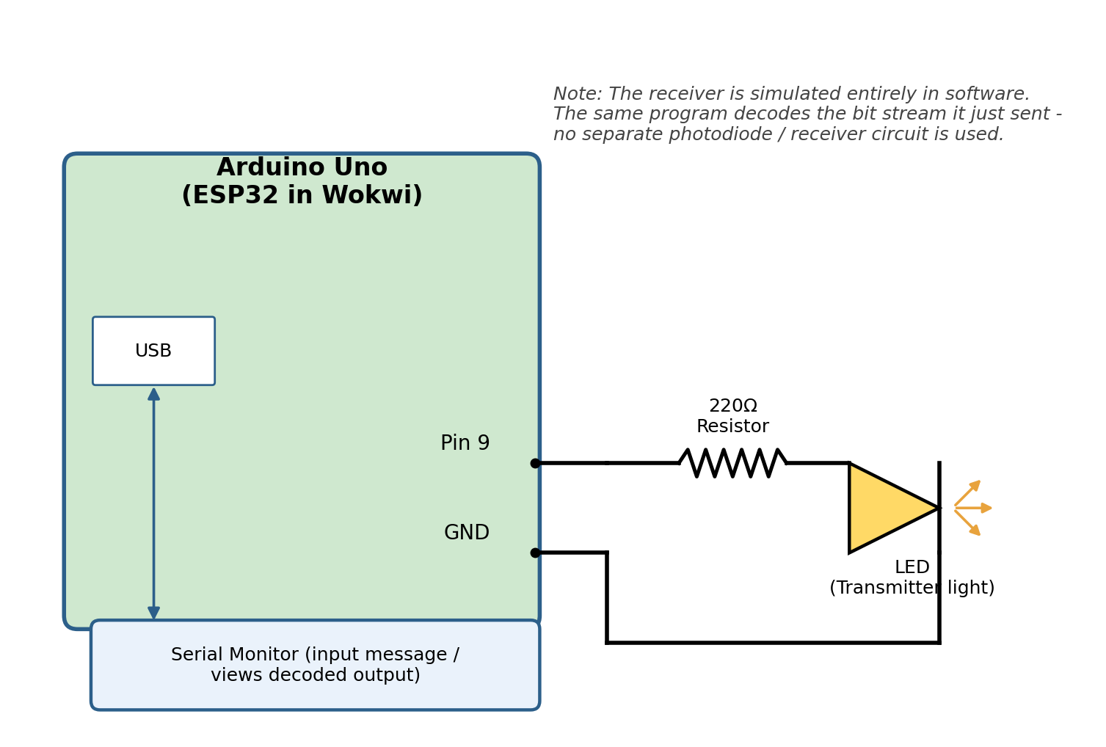

Circuit Explanation
The circuit used in this simulation is intentionally simple, since only the transmitter side needs physical hardware:
- Arduino/ESP32 Board: Acts as the main controller. It runs the sketch that reads the Serial Monitor input and controls the LED.
- LED (connected to Pin 9): Acts as the optical transmitter. It blinks according to the binary bit stream — turned HIGH for bit '1' and LOW for bit '0', with a 100 ms delay between bits.
- 220Ω Resistor: Connected in series with the LED to limit current and protect the LED from damage.
- GND connection: Completes the circuit back to the board's ground pin.
- Serial Monitor (via USB): Used as the input interface (to type the message) and the output interface (to view the encoded bit stream and decoded message).
There is no separate receiver circuit (no photodiode/LDR) in this simulation — the 'reception' of light pulses is simulated directly in software by re-using the bit stream generated during transmission. This keeps the focus on demonstrating the encoding-transmission-decoding logic of Li-Fi rather than the analog light-sensing hardware.

3. Working Principle (How the Code Works)
Stage | What Happens
1. Initialization | LED pin is set as OUTPUT and Serial communication starts at 9600 baud.
2. Input | User types a message into the Serial Monitor and presses Send.
3. Encoding | Each character of the message is converted into its 8-bit binary (ASCII) form.
4. Transmission | For every bit, the LED is switched HIGH (bit = 1) or LOW (bit = 0) with a fixed delay, simulating light pulses. The bits are also stored as a bit-stream string.
5. Reception (simulated) | The captured bit stream is treated as the 'received' signal, exactly as a photodiode would have captured it.
6. Decoding | The bit stream is split into groups of 8 bits, and each group is converted back into a character.
7. Verification | The decoded message is compared with the original message and a Success / Error status is printed.

4. Flow Chart
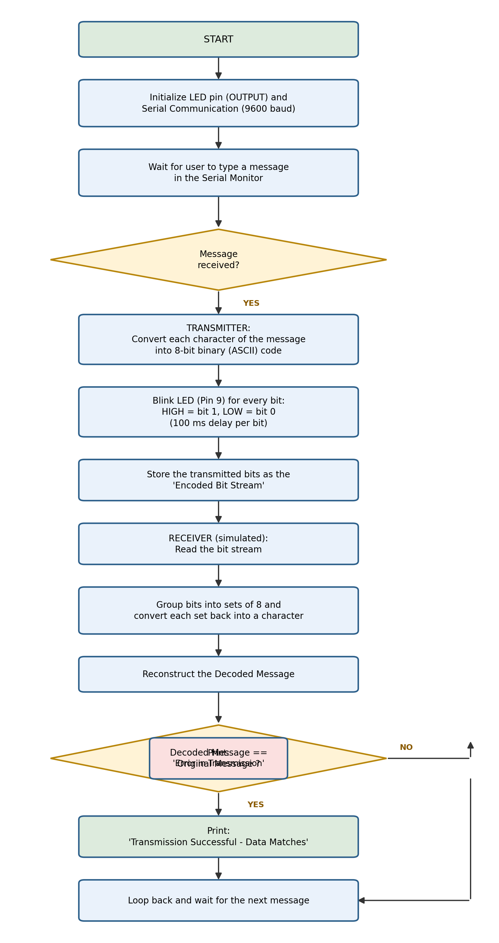

5. Applications & Advantages
- Higher bandwidth potential compared to Wi-Fi, since visible light spectrum is much larger than radio spectrum.
- Can be used safely in areas where RF signals are restricted, e.g. aircraft cabins, hospitals.
- Low-cost demonstration of the Li-Fi concept without requiring photodiode/optical receiver hardware.
- Useful as an educational tool for understanding data encoding, modulation, and serial communication.

6. Conclusion
This project successfully demonstrates the core idea behind Li-Fi communication — encoding data into light pulses and decoding it back into the original message — using a simple, low-cost software simulation on Wokwi. While a real Li-Fi system would use an actual photodiode/LDR to sense the LED's light pulses, this simulation validates the encoding and decoding logic that forms the backbone of any Li-Fi transmission system.

